**Sri Lanka Institute of Information Technology**

**IE2062 - Web Security**

**Final Assignment**

**THM Report**

**Name:** Peiris W.S.S.N

**Registration Number:** IT23227286

Contents

1. Room Overview 3

2. Learning Objectives 4

3. Room Structure 4

4. Room Link 7

5. Reflection 8

# Room Overview

**Topic Title:** **Path Traversal Playground**

[**https://tryhackme.com/jr/pathtraversalplayground**](https://tryhackme.com/jr/pathtraversalplayground)

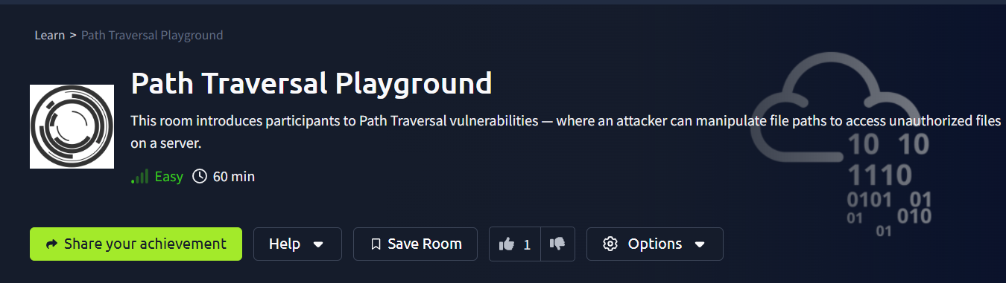

**Room Summary:**

This room gives an introduction to path traversal vulnerability in websites in a beginner friendly way. Participants can explore how improperly handled user inputs can enable attackers to read sensitive files. This is done by manipulating file paths. The room will explain the theory, demonstrate exploitation techniques, and provide hands-on practice in a safe environment. This is the best way to kickstart studying vulnerabilities like path traversal.

**Key Vulnerabilities and Concepts Covered:**

* Path Traversal (../ attack patterns)
* Handling unsafe files in web applications
* Input validation and sanitization techniques
* Prevent traversal attacks with secure coding practices

# Learning Objectives

**By completing this room, participants will:**

* Learns what path traversal is and how it works.
* Identify unsafe file handling in web applications.
* Exploit Path Traversal vulnerabilities to access sensitive files.
* Prevent Path Traversal in code by using basic methods.
* Analyze and secure web application file paths by using critical thinking.

# Room Structure

**Section 1: Introduction**

* **Objective:** Understand the room content
* **Content:** Room overview and Learning objectives
* **Task:** Reading

**Section 2: Introduction to Path Traversal**

* **Objective:** Understand the basic theory.
* **Content:** Short lesson on explaining what Path Traversal is, why it is important, and examples of real-world impact.
* **Task:** Answer a few quiz questions to check understanding.  
    
  **Answers**
* **Q1:**../
* **Q2:** Exposure of sensitive information

**Section 3: Mechanics of Path Traversal**

* **Objective:** Understand the syntax.
* **Content:** A lesson on explaining what can be used for path traversal.
* **Task:** Answer a question to check understanding.

**Answers**

**Q1**: Moves one directory up

**Section 4: Prevention Techniques**

* **Objective:** Understand mitigation techniques.
* **Content:** A lesson on explaining what can be used to prevent path traversal.
* **Task:** Answer questions to check understanding.

**Answers**

**Q1:** validate and sanitize

**Section 5: Challenge**

* **Objective:** Apply the learned skills for hidden file retrieval.
* **Setup:** A new web page to help practice path traversal.
* **Goal:** Find the hidden flag (THM{I_LoVE_PatH_tRaverSal}) stored inside the secret folder.

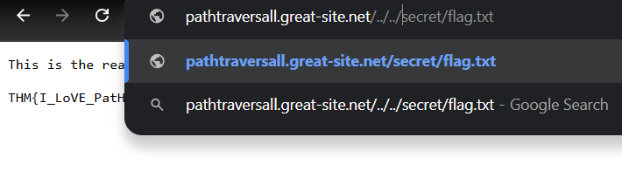

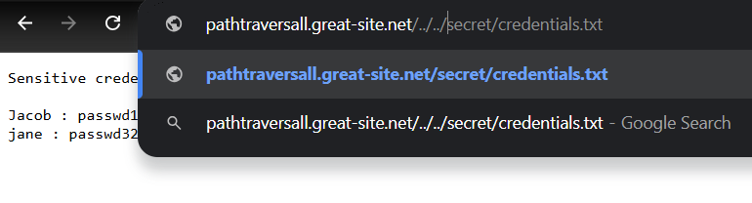

**Expected Outcomes:**

* Participants try to engage in Path Traversal manually.
* Participants will come realization that poorly handled file paths are dangerous.

**Section 6: Conclusion and Key Takeaways**

* **Objective:** Having a clear idea about the vulnerability
* **Content:** Room summary and next steps.
* **Task:** Reading

# Room Link

* **Room Status:** (Draft/Not yet published)
* **THM Room Link:** <https://tryhackme.com/jr/pathtraversalplayground>

# Reflection

**Personal Insights:**  
Researching for this room gave me insights on how dangerous are simple mistakes that happen with file path handling can be. Mistakes in handling file paths can lead to serious security problems. This room also taught me how important it is to teach participants in a step by step guide when they are new to the subject.

**Contribution to the Learning Community:**  
**This room helps newcomers:**

* Introduces to basic web exploitation.
* Gain a real sense of how dangerous un-sanitized inputs are.
* Introduces to two perspectives of an attacker and a defender.
* Get familiar with hands-on skills that will come in handy in CTFs and real-world penetration testing.

THANK YOU!